1. ER Diagram:

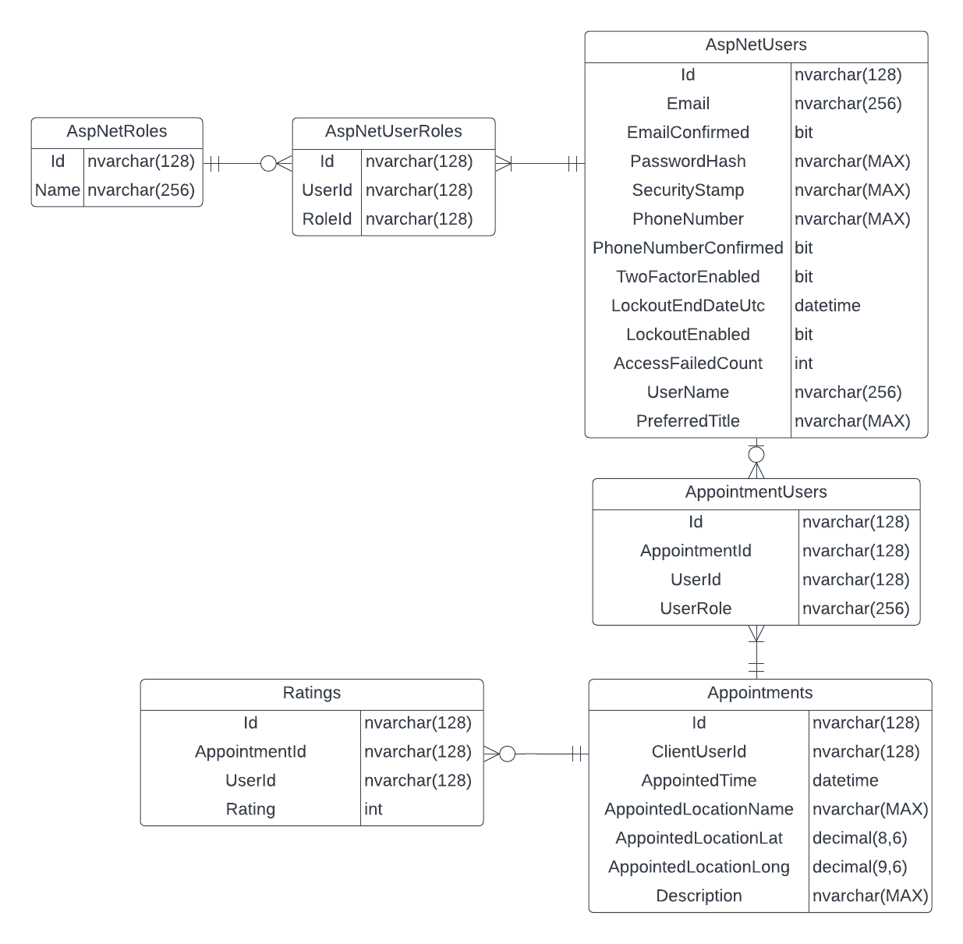

*Figure 1: Entity Relation Diagram.*

The ER Diagram above includes Business Requirements: B.2 (Date Storage), C.1 (Role-based Authentication), D4 (Booking Constraint) and E.2 (Geo Location, since I am storing latitude and longitude values of corresponding booking appointments).

Note that this ER diagram is still subject to change depending on new discoveries whilst I complete the implementation.

2. Implementation of Controller with user registration and authentication.

The default controller providing authentication in my current project is AccountController. Which simply handles the authentication via MS Identity.

Link: <https://github.com/3drdsh3in/FIT5032/blob/master/assignments/portfolio/FIT5032_Assignment_Portfolio/FIT5032_Assignment_Portfolio/Controllers/AccountController.cs>

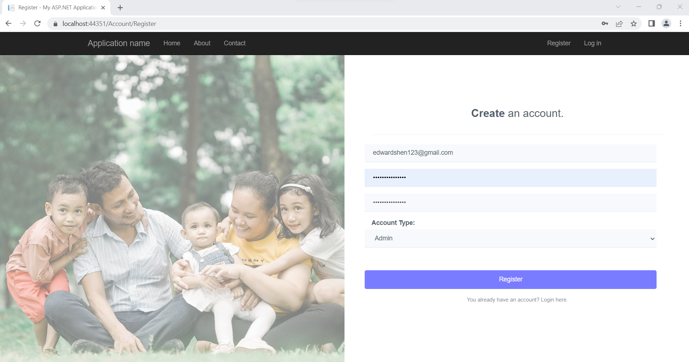

*Figure 2: Registration Form*

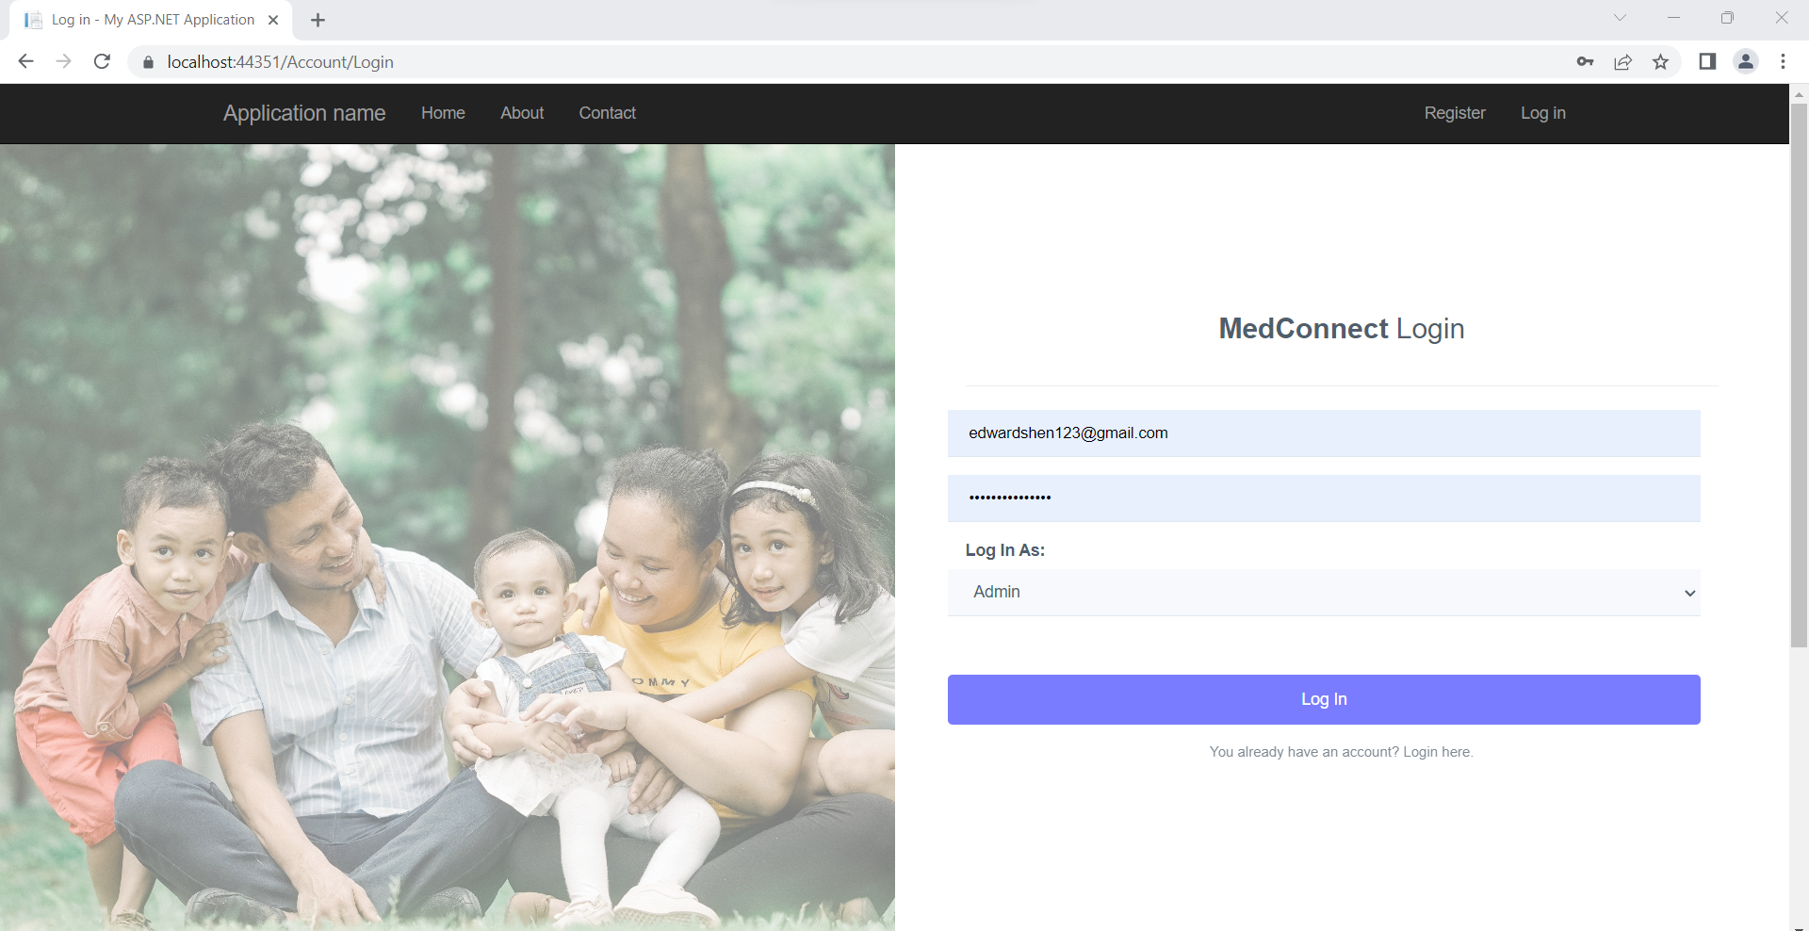

*Figure 3: Logging In*

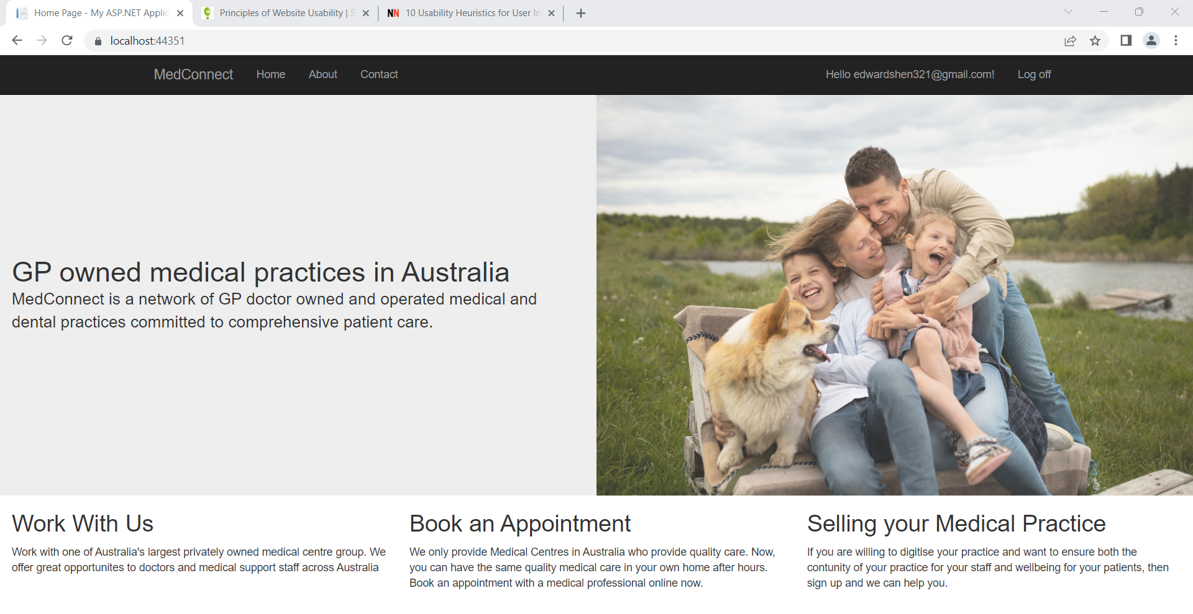

*Figure 4: Log in Screen upon clicking Create or Login.*

3. Implementation of any other Controller and Usability evaluation

Implementation:

Link: <https://github.com/3drdsh3in/FIT5032/blob/master/assignments/portfolio/FIT5032_Assignment_Portfolio/FIT5032_Assignment_Portfolio/Controllers/AppointmentController.cs>

Note that I’m not quite done with this controller. As of this submission only the Get Appointments Endpoint works to a standard, I deem barely acceptable (and even then, the UI still looks awkward). The Create Appointment Endpoint has been implemented in a primitive way to assist with testing the table functionality and will likely be changed to meet other business requirements down the line (Hence, please disregard it entirely for marking).

Usability Evaluation of the web application:

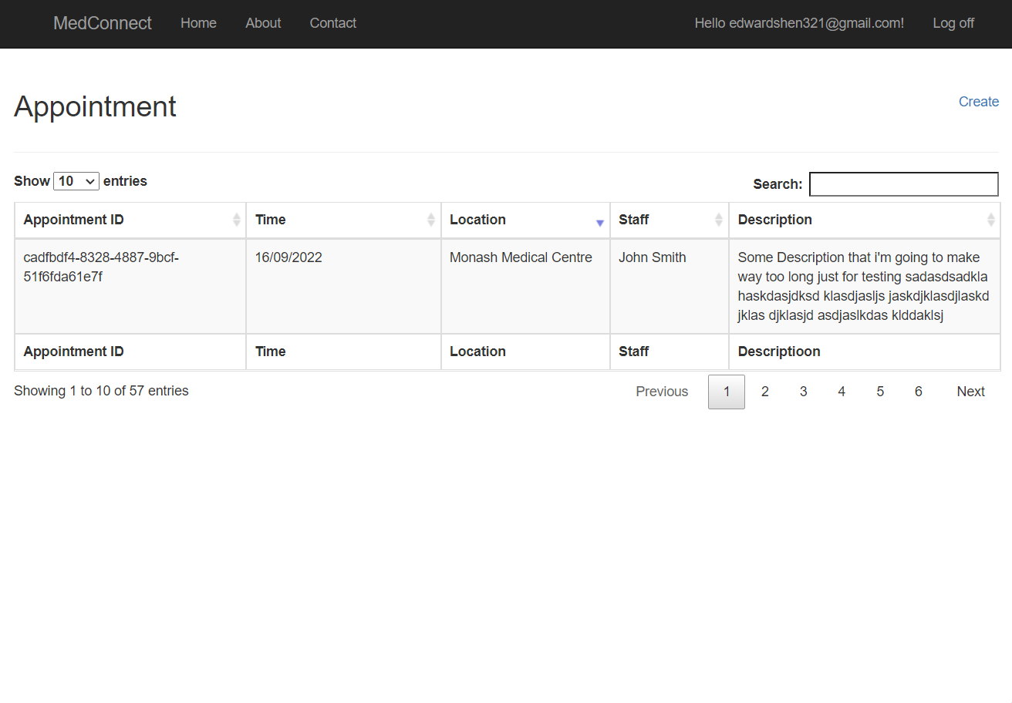

*Figure 5: Table View Implementation for booking appointments.*

The current version of the web application is far from ideal when considering it from a usability standpoint. Common principles of good website design such as consistency (from Donald Norman’s 6 Principles of Design) are not very well met due to a lack of responsiveness that has yet to be implemented (Haven’t had the time to implement this yet). For example, the table view in *Figure 5* (I think) is a bit awkward to read and digest. Without looking too hard we can easily notice misalignments of text being display vertically (The left edge of “MedConnect” title in the Navbar does not align with text beneath which makes it inconsistent with other parts of the website such as the Login/Registration screens where they do align). However, despite the current flaws it possesses I do still think that the current implementation at the very least still possesses some level of visibility and recognisability as it’s not hard to tell that the page in *Figure 5* we are showing is attempting to display an interactive table of appointments (with all the search features etc…). Overall, I believe I still have a long way to go with polishing the UI/UX if I intend on keeping the web app competitive at all from a usability standpoint. In addition to what I’ve already mentioned. This can also be done by better applying the Constraint principle by restricting my table UI to fewer options (Example: Only displaying the option to select the page numbers larger than 2 inside the table when there are enough rows in the table to completely fill those pages. The Mapping Principle could also be applied by adding more icons to my buttons and menus.